General Human Biology

Task 3 – Respiratory & Circulatory Systems Test

NAME: WEIGHTING: 10%

DATE: MARK: _____ /51 = _____ %

**Section One- MULTIPLE CHOICE 19 Marks**

Circle the most correct answer on the test paper below

1. Air enters the body and travels to the lungs through the-
   1. nose and the trachea
   2. oesophagus and trachea
   3. trachea and the oesophagus
   4. nose and mouth
2. What is the purpose of the little hairs inside the nose?
   1. To fight disease.
   2. They serve no purpose.
   3. To keep dust out of the lungs.
   4. To tickle the nose and cause sneezes.
3. What happens to the trachea, before it reaches the lungs?
   1. It branches in two directions.
   2. It branches in three directions.
   3. It vibrates and creates sounds.
   4. It closes up so that no oxygen can escape.
4. What important activity takes place in the lungs?
   1. Food is digested.
   2. Liquid waste is filtered from the blood.
   3. Oxygen is exchanged for carbon dioxide.
   4. The trachea is exchanged for the larynx.
5. Which organ is made up of air-carrying tubes and tiny sacs?
   1. The brain
   2. The lungs
   3. The stomach
   4. The diaphragm
6. What body structure protects the lungs from outside harm?
   1. Cartilage
   2. Tiny sacs
   3. The rib cage
   4. The diaphragm
7. Why is there cartilage in the trachea?
   1. to trap particles
   2. to join it to the oesophagus
   3. there is no cartilage
   4. to keep the airway open
8. Which type of blood vessels carries blood away from the heart?
   1. Veins
   2. Arteries
   3. Capillaries
   4. Arteries, veins and capillaries
9. Why is blood that flows from the lungs to the heart bright red rather than dark red?
   1. Oxygen makes it red.
   2. Carbon dioxide makes it red.
   3. Gastric juices produce the red colour of the blood.
   4. The lungs add a pigment (dye) to blood as it flows through them.
10. What part of the blood carries minerals, vitamins, glucose, and water to the body's cells?
    1. White blood cells
    2. Platelets
    3. Red blood cells
    4. Plasma
11. What is the main job of the red blood cell in the blood?
    1. To clot blood
    2. To fight disease
    3. To transport oxygen to the body's cells and carry away carbon dioxide from the cells
    4. To transport carbon dioxide to the body's cells and carry away oxygen from the cells
12. Which of the following protects the body from invading organisms?
    1. Lungs
    2. Capillaries
    3. Red blood cells
    4. White blood cells
13. If a person had A type blood?
    1. They would have B antigens
    2. They would be able to donate to O type blood
    3. They could receive AB blood
    4. They could receive blood from an O type blood person.
14. What happens when a clot occurred in an undamaged blood vessel?
    1. You would bleed to death.
    2. A scab will form on the skin surface.
    3. Platelets stick to the edges of the cut and to one another, forming a plug.
    4. The flow of blood to tissues beyond the clot may be cut off.
15. What happens to blood when it is pumped into the thin-walled blood vessels of the lungs?
    1. Platelets are exchanged for plasma.
    2. Carbon dioxide is replaced with oxygen.
    3. Blood fills the lungs and causes coughing.
    4. Nothing -- the lungs are just a place blood goes through on its way back to the heart.
16. What is the function of the blood vessels and capillaries?
    1. They pump blood to the heart.
    2. They filter impurities from the blood.
    3. They carry blood to all parts of the body.
    4. They carry messages from the brain to the muscles.
17. How many major types of blood have scientists discovered?
    1. One: Type "O"
    2. Two: white cells and red cells
    3. Three: white cells, red cells, and plasma
    4. Four: Types A, B, AB, and O
18. What is the organ that pumps blood all throughout the human body?
    1. The lungs
    2. The heart
    3. The kidneys
    4. The blood vessels and capillary.
19. A stroke is caused by:
    1. Blood clots
    2. Blocked artery
    3. Flying
    4. Poor diet

**Section Two- Short Answer Questions 32 marks**

1. Draw a labelled diagram below to show how gas diffusion occurs in the lungs. (4 marks)
2. Mrs Cooper walked in one day and hear Miss Roberts saying that the position of the lungs is very important. Explain why Miss Roberts would say this. (3 marks)

1. Complete the table below (6 marks)

|  |  |  |
| --- | --- | --- |
| **Blood Vessel** | **Features** | **Drawing** |
| **Artery** |  |  |
| **Vein** |  |  |
| **Capillary** |  |  |

1. Describe the function of red blood cells and the importance of its shape. (4 marks)

1. Describe how breathing occurs in the respiratory system. Use diagrams to support your answer. (6 marks)

1. Cystic Fibrosis is a condition where people produce an abnormal amount of excessively thick and sticky mucous within the lungs and airways. Explain using your knowledge of the respiratory system two symptoms you would expect and why. (4 marks)

1. Using the diagram of the heart below explain how its structure allows for efficient blood flow around the body. (5 marks)

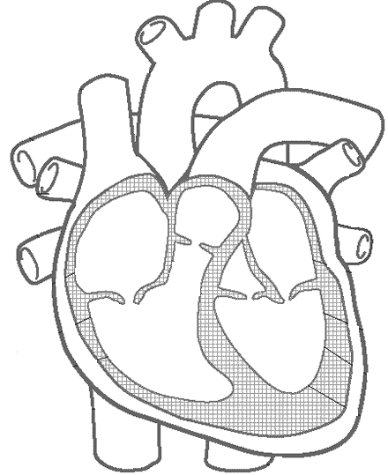

**End of Test**